DRIVING SCHOOL
Step 0: Create a repository in Github called DrivingSchool and connect after create the app in NetBeans.
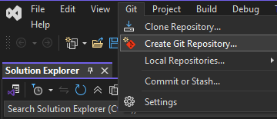
Step 1: Create an MVC Web Application Project
1. Open Visual Studio.
2. Click File > New > Project.
3. Select Visual C# > Web > ASP.NET Web Application (.NET Framework).
4. Enter the project name, e.g., DrivingSchool, and choose a location.
5. Click OK

Step 2: Install Entity Framework via NuGet

